**Program that will retrieve student data from a text file and display it.**

**Pre-populate data in Notepad:**

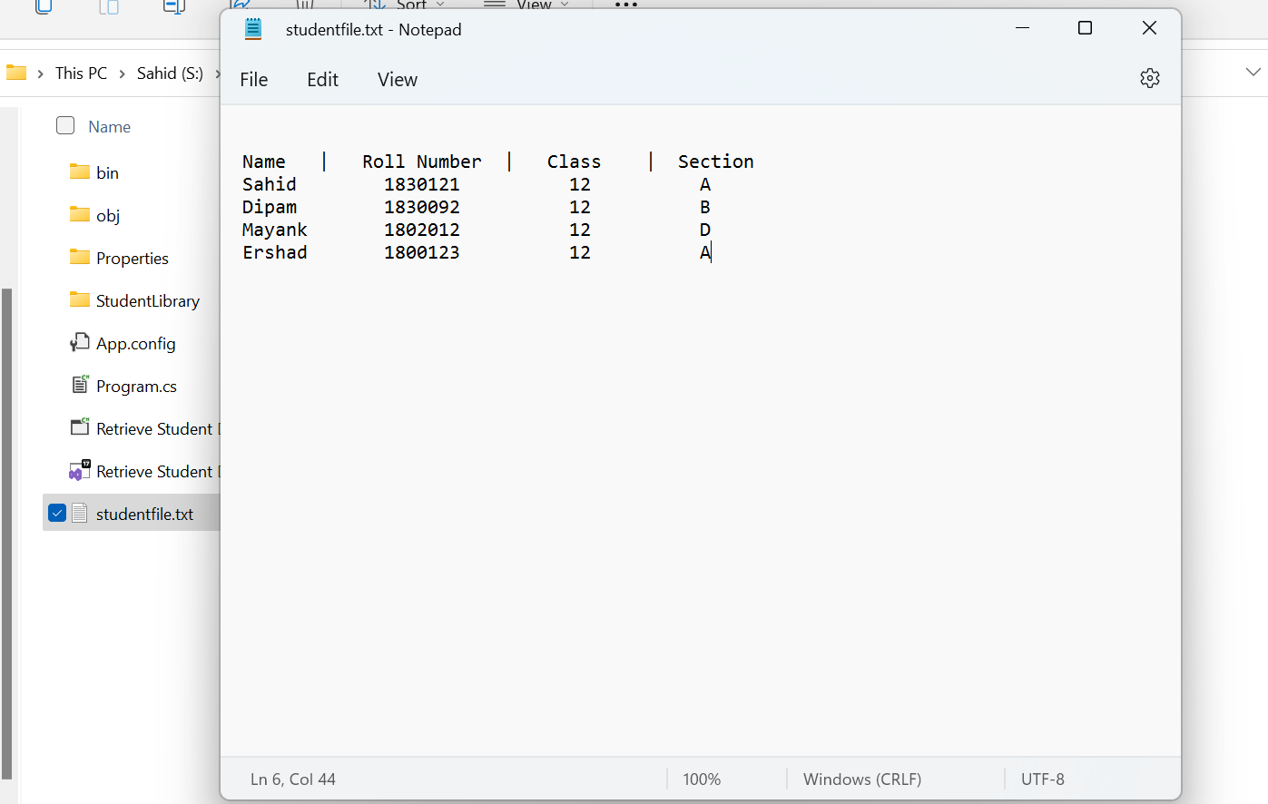

**Program that will retrieve the data from studentsfile.txt:**

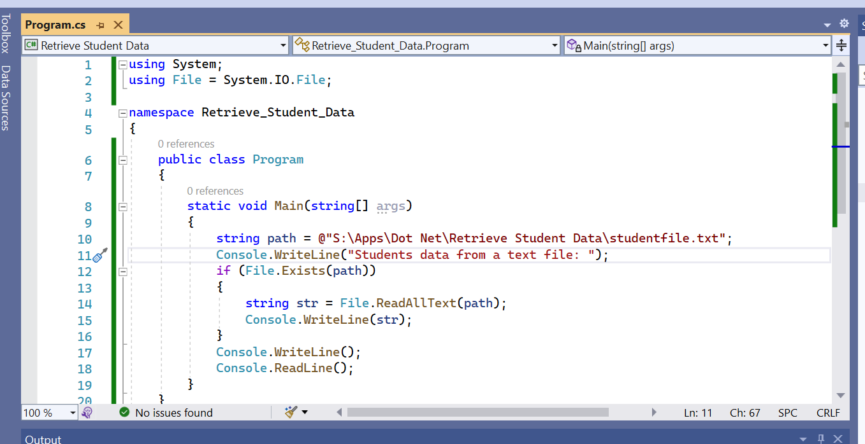

**Output of Program that will retrieve the data from studentsfile.txt:**

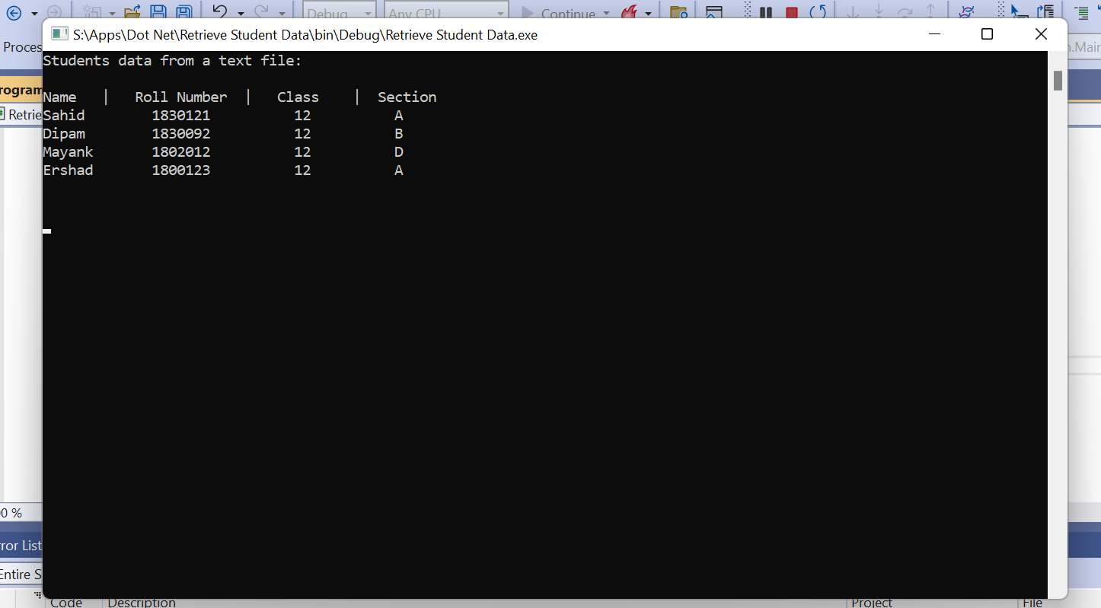

**Sahid Ali Khan**

**2529998**